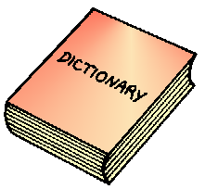
Use a dictionary to explain the meaning of words in the context they are written.

TOP TIP:
Skim the text and underline any unknown words.


Retrieve information and identify key details from fiction and non-fiction (factual).
A
TOP TIP:
Scan the text for the key word in the question and highlight the whole sentence.
B
SUMmarise the main ideas from every paragraph.
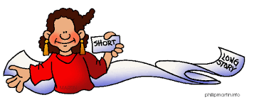
TOP TIP:
Shorter than the text.
Use your own words.
Main ideas only.
C
Make inferences from the text and explain using the evidence.
TOP TIP:
Use clues in the text to discover what is not directly stated.

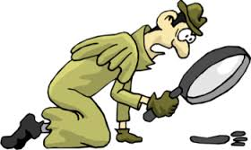
D
Text: Hannah collected shells; then she went for a cool swim in the salty water.
Inference: Hannah is at the ocean.

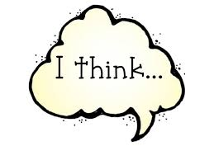
Predict what might happen from details stated and implied.

TOP TIP:
What has happened already?
Think about what you know.
Take a guess at what will happen next.

E
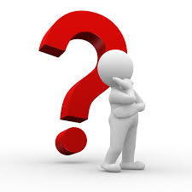
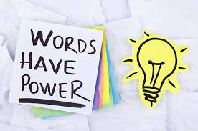
Explain why the writer has chosen the characters, illustrations, title, text organisation the way they have.
Explain how meaning is enhanced through the choice of words and phrases.
F
TOP TIP:
A good writer will sometimes search hours for just the right word. Think about WHY they have chosen that exact word or phrase.

G
Make comparisons within the text.
TOP TIP:
Using a Venn diagram can help you understand how things are the same and how they are different.

For example: Taylor likes football and basketball. Which one does he like the best?
Basketball
Football
H
Plays with his friends when he has time.
Plays every Saturday and is in the school team.
Enjoys ball games


