Geography Medium Term Planning Overview
Year Group: |  |  | 5 |  | Period / Time Allocation: |  |  | Summer 1
Theme: | OS Map Skills and Fieldwork
Prior Knowledge
Year 4 Water cycle and rivers Year 4 Latitude and longitude Year 4 Environmental regions of Europe, Russia N and S America Year 5 World countries and biomes Year 5 4 and 6 figure grid references
Vocabulary
Prior |  |  |  |  |  | Current
Compass, features, location, physical, region, symbol |  |  |  |  |  | Contrast, intersect, slope, solar, farm, turbine, undulating, coordinates, contour line, easting, northing, plateau, terrain
Teaching Sequence: Lessons
1 |  | 2 |  | 3 |  |  | 4 |  | 5 | 6
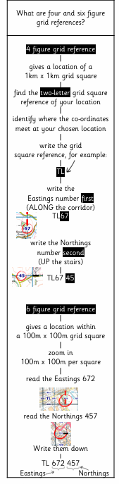 |  | 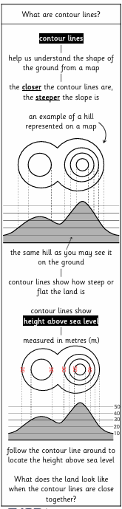 |  | 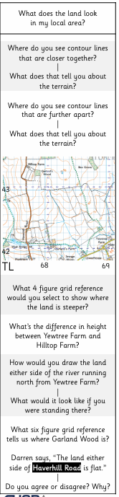 |  |  | 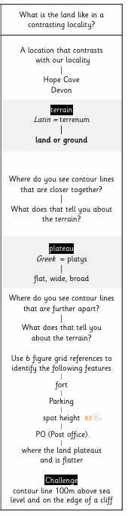 |  |  | Review and Assess  Socrative Quiz  Opportunities for enrichment, OOA, writing / spoken language outcomes
OOA Opportunities
TO BE ADDED THROUGHOUT THE YEAR

