Geography Medium Term Planning Overview
Year Group: |  |  | 3 |  | Period / Time Allocation: |  |  | Summer 1
Theme: | OS Map Skills and Fieldwork
Prior Knowledge
Y2 Fieldwork and map skills (compass)
Y3 Fieldwork and map skills Y3 UK Study Y3 Revisit human and physical features
Vocabulary
Prior |  |  |  |  |  | Current
compass, features, location, physical, region, symbol |  |  |  |  |  | Area, cardinal, historic, landscape, measuring, solar,  Geographical, key, ordinance, scale, survey, sustainable
Teaching Sequence: Lessons
1 |  | 2 |  | 3 |  |  | 4 |  | 5 | 6
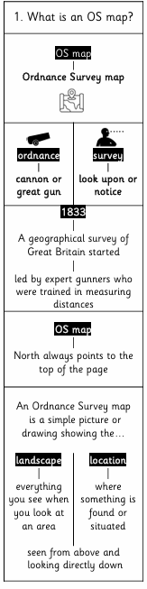 |  | 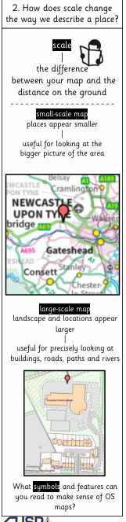 |  | 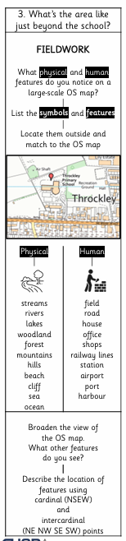 |  |  |  |  |  | Review and Assess  Socrative Quiz  Opportunities for enrichment, OOA, writing / spoken language outcomes
OOA Opportunities
TO BE ADDED THROUGHOUT THE YEAR

