Geography Medium Term Planning Overview
Year Group: |  |  | 1 |  | Period / Time Allocation: |  |  | Summer 1
Theme: | Mapping and fieldwork
Prior Knowledge
EYFS People, Culture and Communities Year 1 Introduce UK countries, capital cities, continents and oceans.

Vocabulary
Prior |  |  |  |  |  | Current
Map, outdoors, indoors |  |  |  |  |  | Built, human, imaginary, natural, place, space  Aerial, connected, environment, feature, fieldwork, location
Teaching Sequence: Lessons
1 |  | 2 |  | 3 |  |  | 4 |  | 5 | 6
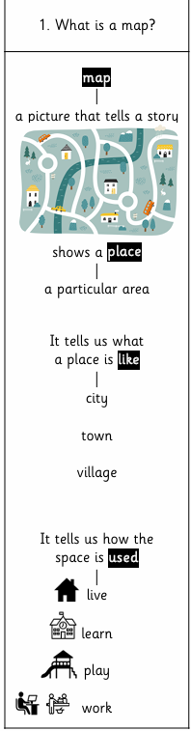 |  | 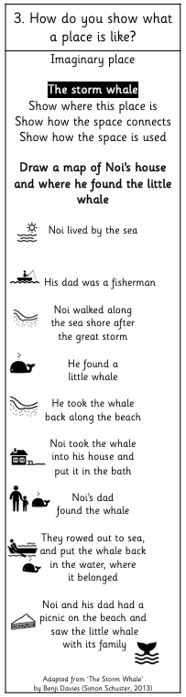 |  | 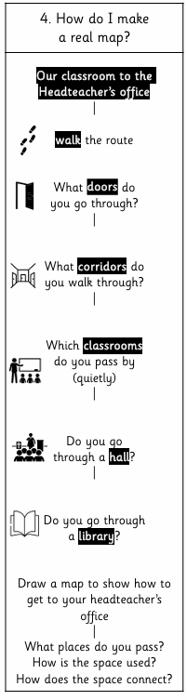 |  |  |  |  |  | Review and Assess  Socrative Quiz  Opportunities for enrichment, OOA, writing / spoken language outcomes
OOA Opportunities
TO BE ADDED THROUGHOUT THE YEAR

