History Medium Term Planning Overview
Year Group: |  |  | 3 |  | Period / Time Allocation: |  |  | Spring 2
Theme: | The Roman Empire and its impact on Britain
Prior Knowledge
Year 2: Beyond living memory, significant events, local and national (Great Fire of London, Local: Liverpool (transport)
Year 3: Stone Age to Iron Age
Vocabulary
Prior |  |  |  |  |  | Current
Peaceful, equipment, traditional, local, retreated |  |  |  |  |  | Tier 2: previously, conquered, rebellion, luxurious, culture, settlement  Tier 3: amphitheatre, emperor, aqueduct, invasion, barbarian, forum
Teaching Sequence: Lessons
1(E) |  | 2 (E) |  | 4 (E) |  |  | 5(E) |  | 6/7 (E) | 8 (E)
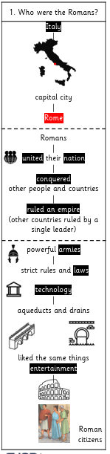 |  | 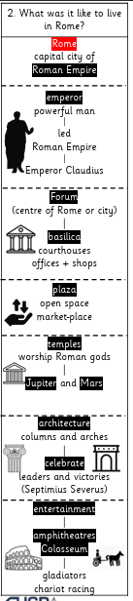 |  | 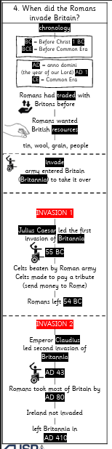 |  |  | 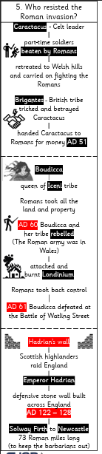 |  | 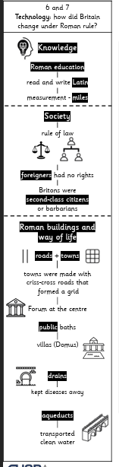 | 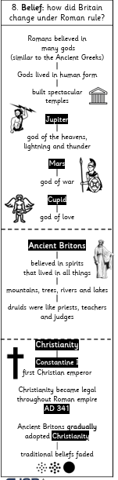  Review and Assess  Socrative Quiz  Opportunities for enrichment, OOA, writing / spoken language outcomes
OOA Opportunities
TO BE ADDED THROUGHOUT THE YEAR

