History Medium Term Planning Overview
Year Group: |  |  | 1 |  | Period / Time Allocation: |  |  | Autumn 2
Theme: | The lives of significant people (Mary Anning and David Attenborough)
Prior Knowledge
ELG – Understanding the world: Past and Present and People, Culture and Communities
Personal timeline and chronology
Vocabulary
Prior |  |  |  |  |  | Current
past, change, same, different |  |  |  |  |  | Tier 2: legacy, inspire, revealed, explore, similar  Tier 3: fossil, documentary, significant, naturalist, expedition
Teaching Sequence: Lessons
1(NE) |  | 2 (E) |  | 3 (E) |  |  | 4 (E) |  | 5 (E) | 6 (NE)
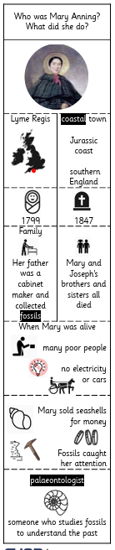 |  | 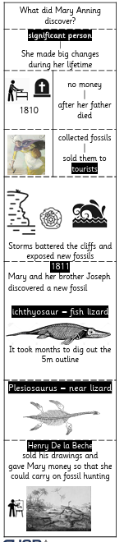 |  | 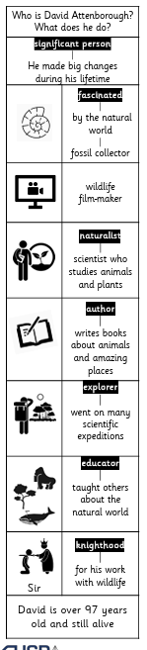 |  |  | 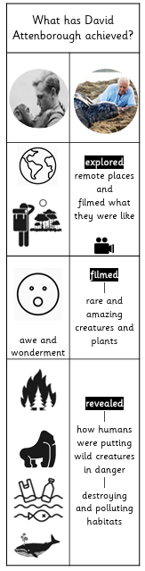 |  | 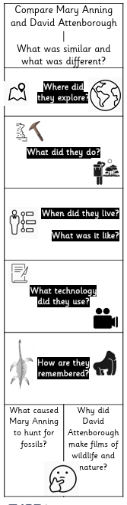
OOA Opportunities
TO BE ADDED THROUGHOUT THE YEAR

