Science Medium Term Planning Overview
Year Group: |  |  | 6 |  |  | Period / Time Allocation: |  |  | Summer 2
Theme: | Evolution and inheritance
Prior Knowledge
Science Y3 Rocks
Geography Y4 Water cycle
Science Y5 Life cycles and reproduction Science Y5 Animals, including humans Science Y5 Properties and changes of materials
Science Y6 Classification
Vocabulary
Prior |  |  |  |  |  |  | Current
vary, variation reproduce, reproduction descend, descendent diverse, diversity, diversify |  |  |  | vary, variation reproduce, reproduction descend, descendent diverse, diversity, diversify |  |  | Tier 2: characteristic, adaptation, acquire, theory, modify, generation. |  |  |  | Tier 3: evolve, survival, species, clone, inherit fossil.
Teaching Sequence: Lessons
1 (E) |  | 2 (E) |  |  | 3 ( E) |  |  | 4(En) |  | 5 (E) |  | 6(E)
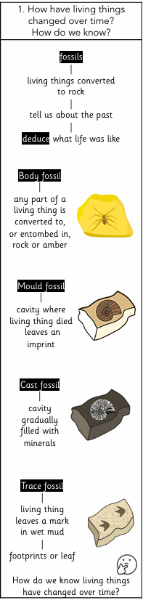 |  | 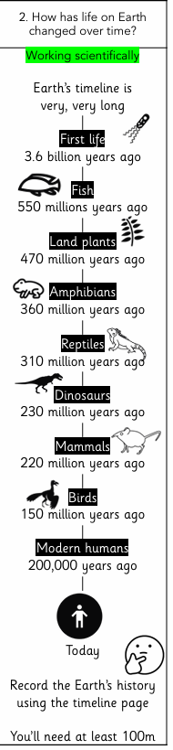 |  |  | 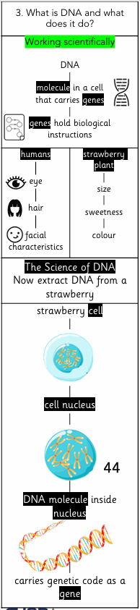 |  |  | 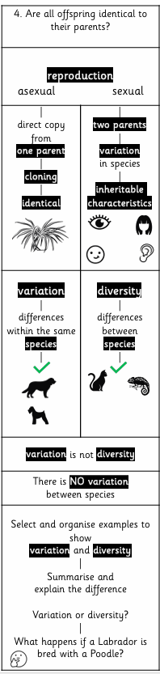 |  | 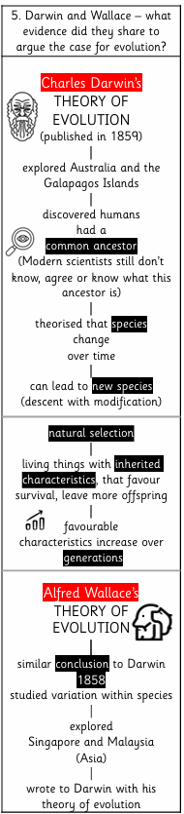 |  | Review and Assess  Socrative Quiz  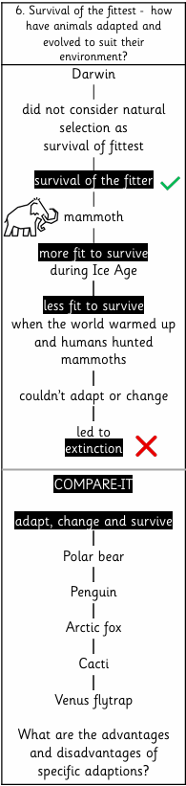
OOA Opportunities

