Science Medium Term Planning Overview
Year Group: |  |  | 4 |  |  | Period / Time Allocation: |  |  | Autumn 2
Theme: | Electricity
Prior Knowledge
Year 3 Light reflection, sources and shadow
Year 3 Forces and magnets forces attract and repel
Year 4 Sound source, vibrations, pitch and volume
Vocabulary
Prior |  |  |  |  |  |  | Current
perimeter complete, completion recharge |  |  |  | perimeter complete, completion recharge |  |  | Tier 2: associate, identify, portable, effect, appliance, series. |  |  |  | Tier 3: component, electrical insulator, electrical conductor, circuit, hypothesis, variable.
Teaching Sequence: Lessons
1 (E) |  | 2 (E) |  |  | 3 ( E) |  |  | 4 (E) |  | 5 (E) |  | 6(En)
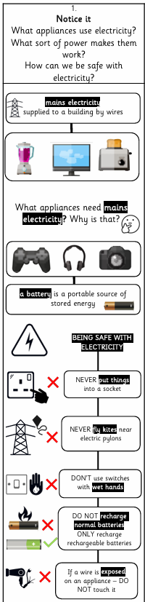 |  | 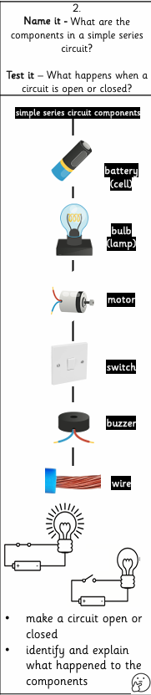 |  |  | 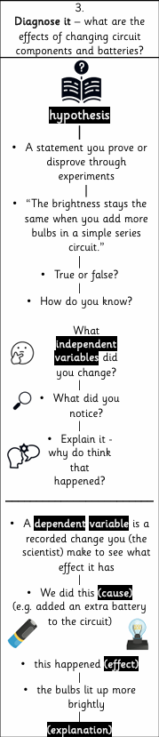 |  |  | To consolidate learning, if needed  Or complete scientific enquiry  The learning questions can be taught over more than one lesson, if needed. Remember these: Connect, Explain, Example, Attempt, Apply and Challenge |  |  |  | Review and Assess  Socrative Quiz
OOA Opportunities

