Science Medium Term Planning Overview
Year Group: |  |  | 2 |  |  | Period / Time Allocation: |  |  | Autumn 2
Theme: | Animals including Humans
Prior Knowledge
EYFS: The Natural World Explore the natural world around them, making observations and drawing pictures of animals and plants.
EYFS: The Natural World Understand some important processes and changes in the natural world around them, including the seasons and changing states of matter.
EYFS: The Natural World Know some similarities and differences between the natural world around them and contrasting environments, drawing on their experiences and what has been read in class.
Year 1 Plants Everyday materials Animals, including humans
Year 2 Living things and their habitats
Vocabulary
Prior |  |  |  |  |  |  | Current
mammal, amphibian, reptile carnivore, herbivore, omnivore |  |  |  | mammal, amphibian, reptile carnivore, herbivore, omnivore |  |  | Tier 2: healthy, survive, exercise, heart, lungs, muscles. |  |  |  | Tier 3: hygiene, larva, pupa, vertebrates, invertebrates, metamorphosis.
Teaching Sequence: Lessons
1 (E) |  | 2 (Enrich) |  |  | 3 ( E) |  |  | 4 (Enrich) |  | 5 (E) |  | 6(E)
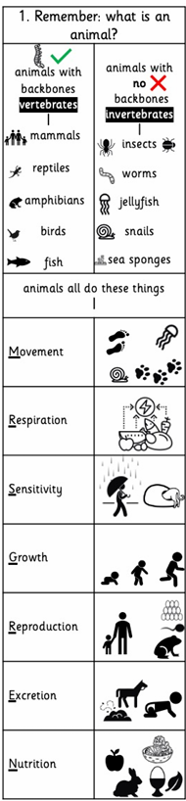 |  | 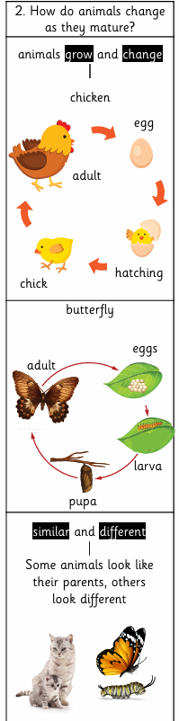 |  |  | 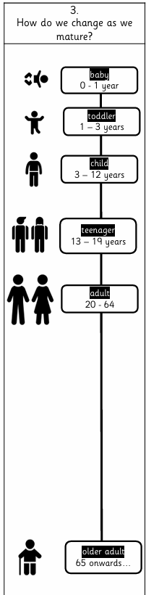 |  |  | 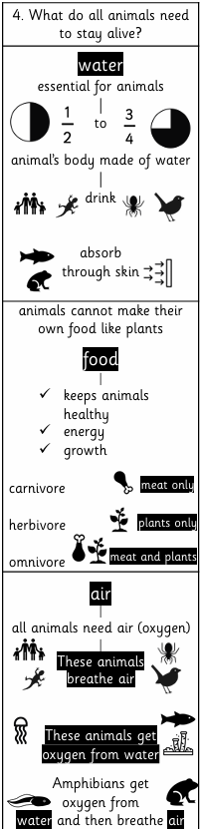 |  | 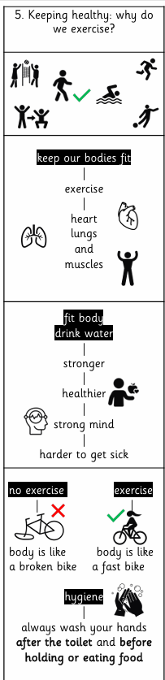 |  | # 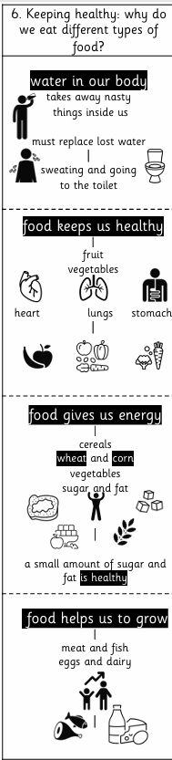  Review and Assess  Socrative Quiz
OOA Opportunities

