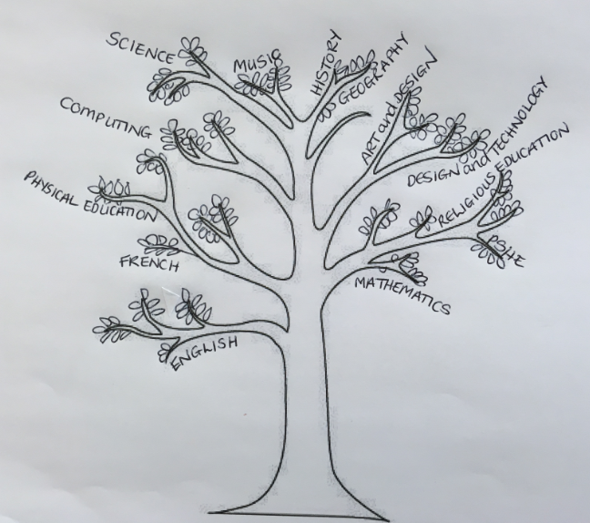

Geography

The United Kingdom.
Locating and identifying counties and major cities.
Comparing different locations with the UK.
Identifying changes over time within the UK.

RE/PHSE

Design and Technology
Hydraulic mechanisms.
We will be making hydraulic head puppets!
Mathematics
Fractions:
Identify unit and non-unit fractions; compare fractions; find fractions of an amount.
Measure:
Measure, compare and an subtract in different units.
Find the perimeter of a simple shape.
Add and subtract amounts of money.
Tell and write the time.

English
Text-based learning: Big Blue Whale by Nicola Davies. This is a beautiful non-fiction text that we will be using to help us write persuasively.
Science
Rocks. Including the rock cycle of igneous, metamorphic and sedimentary rocks.
Music
Three Little Birds and glockenspiel skills.
Spanish
Classroom language.
Animals.
Physical Education
Attacking and defending in invasion games

Computing
Scratch coding

