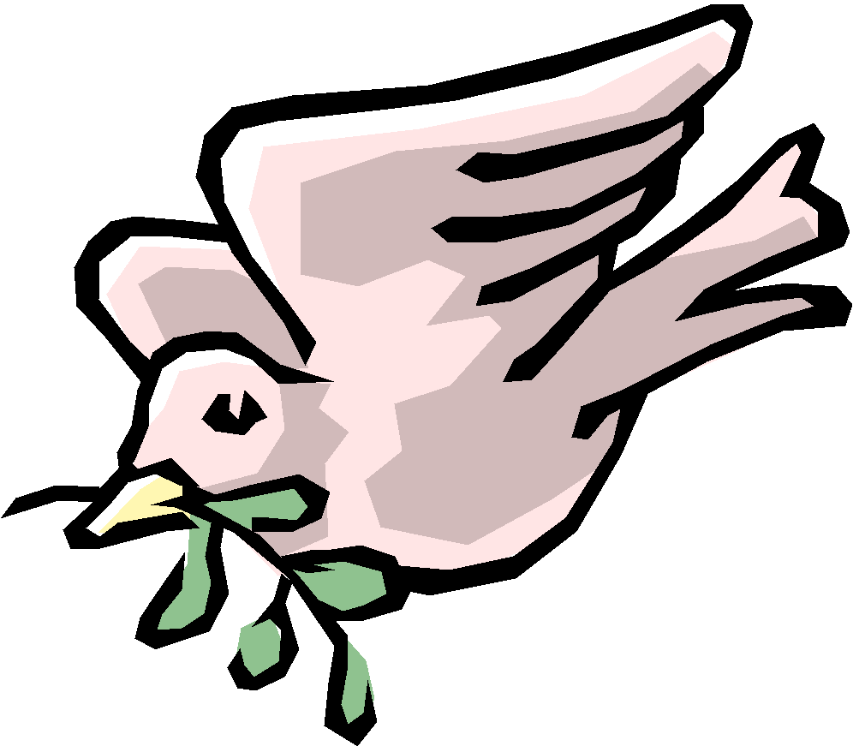 | Progression of Knowledge and Skills  DT

EYFS
Nursery |  | Explore different materials freely, to develop their ideas about how to use them and what to make.  • Develop their own ideas and then decide which materials to use to express them.  • Join different materials and explore different textures.
Reception |  | Return to and build on their previous learning, refining ideas and developing their ability to represent them.  Create collaboratively sharing ideas, resources and skills.
 |  | Design | Make | Evaluate
Year One | Skills | • Design appealing products for a particular user based on simple design criteria.  • Generate initial ideas and design criteria through own experiences.  • Develop and communicate these ideas through talk and drawings and mock ups where relevant. | • Select and use simple utensils, tools and equipment to perform a job e.g. peel, cut, slice, squeeze, grate and chop safely; marking out, cutting, joining and finishing; cut, shape and join paper and card.  • Select from a range of ingredients and materials according to their characteristics to create a chosen product. | • Taste, explore and evaluate a range of products to determine the intended user’s preferences for the product  • Evaluate their ideas throughout and finished products against design criteria, including intended user and purpose.
Year One | Vocabulary | planning, investigating design, evaluate, make, user, purpose, ideas, product,
Year One |  | Structures | Mechanisms | Cooking
Year One | Knowledge | • Know how to make freestanding structures stronger, stiffer and more stable.  • Know and use technical vocabulary relevant to the project. | • Explore and use sliders and levers.  • Understand that different mechanisms produce different types of movement.  • Know and use technical vocabulary relevant to the project. | • Understand where a range of fruit and vegetables come from e.g. farmed or grown at home.  • Understand and use basic principles of a healthy and varied diet to prepare dishes, including how fruit and vegetables are part of The eatwell plate.  • Know and use technical and sensory vocabulary relevant to the project.
Year One | Vocabulary | cut, fold, join, fix  structure, wall, tower, framework, weak, strong, base, top, underneath, side, edge, surface, thinner, thicker, corner, point, straight, curved, metal, wood, plastic  circle, triangle, square, rectangle, cuboid, cube, cylinder | slider, lever, pivot, slot, bridge/guide, card, masking tape, paper fastener, join, pull, push, up, down, straight, curve, forwards, backwards | fruit and vegetable names, names of equipment and utensils  sensory vocabulary e.g. soft, juicy, crunchy, sweet, sticky, smooth, sharp, crisp, sour, hard  flesh, skin, seed, pip, core, slicing, peeling, cutting, squeezing, healthy diet, choosing, ingredients,
Year Two |  | Design | Make | Evaluate
Year Two | Skills | • Generate ideas based on simple design criteria and their own experiences, explaining what they could make.  • Develop, model and communicate their ideas through talking, mock-ups and drawings. | • Plan by suggesting what to do next.  • Select and use tools, equipment, skills and techniques to perform practical tasks, explaining their choices.  • Select new and materials, components, reclaimed materials and construction kits to build and create their products.  • Use simple finishing techniques suitable for the products they are creating. | • Explore a range of existing products related to their design criteria.  • Evaluate their product by discussing how well it works in relation to the purpose, the user and whether it meets the original design criteria.
Year Two | Vocabulary | investigating, planning, design, make, evaluate, user, purpose, ideas, design criteria, product, function
Year Two |  | Mechanisms | Textiles | Cooking
Year Two | Knowledge | • Explore and use wheels, axles and axle holders.  • Distinguish between fixed and freely moving axles.  • Know and use technical vocabulary relevant to the project. | Understand how simple 3-D textile products are made, using a template to create two identical shapes.  • Understand how to join fabrics using different techniques e.g. running stitch, glue, over stitch, stapling.  • Explore different finishing techniques  • Know and use technical vocabulary relevant to the project. | • Understand where a range of fruit and vegetables come from e.g. farmed or grown at home.  • Understand and use basic principles of a healthy and varied diet to prepare dishes, including how fruit and vegetables are part of The eatwell plate.  • Know and use technical and sensory vocabulary relevant to the project.
Year Two | Vocabulary | vehicle, wheel, axle, axle holder, chassis, body, cab assembling, cutting, joining, shaping, finishing, fixed, free, moving, mechanism names of tools, equipment and materials used | joining and finishing techniques, tools, fabrics and components, template, pattern pieces, mark out, join, decorate, finish | fruit and vegetable names, names of equipment and utensils  sensory vocabulary e.g. soft, juicy, crunchy, sweet, sticky, smooth, sharp, crisp, sour, hard  flesh, skin, seed, pip, core, slicing, peeling, cutting, squeezing, healthy diet, choosing, ingredients
 |  | Design | Make | Evaluate
Year Three | Skills | • Generate realistic ideas through discussion and design criteria for an appealing, functional product fit for purpose and specific user/s.  • Use annotated sketches, prototypes, final product sketches and pattern pieces; communication technology, such as web-based recipes, to develop and communicate ideas. | • Plan the main stages of making.  • Select from and use a range of appropriate utensils, tools and equipment with some accuracy related to their product.  • Select from and use finishing techniques suitable for the product they are creating. | • Investigate a range of 3-D textile products, ingredients and lever and linkage products relevant to their project.  • Test their product against the original design criteria and with the intended user.  • Evaluate the ongoing work and the final product with reference to the design criteria and the views of others.
Year Three | Vocabulary | user, purpose, design, model, evaluate, prototype, annotated sketch, functional, innovative, investigate, label, drawing, function, planning, design criteria, annotated sketch, appealing
Year Three |  | Structures | Mechanisms | Cooking
Year Three | Knowledge | • Develop and use knowledge of how to construct strong, stiff shell structures.  • Develop and use knowledge of nets of cubes and cuboids and, where appropriate, more complex 3D shapes.  • Know and use technical vocabulary relevant to the project. | • Understand and use lever and linkage mechanisms.  • Distinguish between fixed and loose pivots.  • Know and use technical vocabulary relevant to the project. | • Know how to use appropriate equipment and utensils to prepare and combine food.  • Know about a range of fresh and processed ingredients appropriate for their product, and whether they are grown, reared or caught.  • Know and use relevant technical and sensory vocabulary appropriately.
Year Three | Vocabulary | shell structure, three-dimensional (3-D) shape, net, cube, cuboid, prism, vertex, edge, face, length, width, breadth, capacity, marking out, scoring, shaping, tabs, adhesives, joining, assemble, accuracy, material, stiff, strong, reduce, reuse, recycle, corrugating, ribbing, laminating, font, lettering, text, graphics, decision, | mechanism, lever, linkage, pivot, slot, bridge, guide  system, input, process, output  linear, rotary, oscillating, reciprocating | name of products, names of equipment, utensils, techniques and ingredients  texture, taste, sweet, sour, hot, spicy, appearance, smell, preference, greasy, moist, cook, fresh, savoury, hygienic, edible, grown, reared, caught, frozen, tinned, processed, seasonal, harvested healthy/varied diet
Year Four |  | Design | Make | Evaluate
Year Four | Skills | • Generate and clarify ideas through discussion with peers to develop design criteria to inform the design of products that are fit for purpose, aimed at particular individuals or groups.  • Use annotated sketches and appropriate information and communication technology, such as web-based recipes, to develop and communicate ideas.  • Generate, develop, model and communicate realistic ideas through discussion and, as appropriate, annotated sketches, cross-sectional and exploded diagrams. | • Order the main stages of making.  • Select and use appropriate tools to measure, mark out, cut, score, shape and combine with some accuracy related to their products.  • Explain their choice of materials according to functional properties and aesthetic qualities.  • Select from and use materials and components, including ingredients, construction and electrical components according to their function and properties. | • Investigate and evaluate a range of products including the ingredients, materials, components and techniques that are used.  • Test and evaluate their own products against design criteria and the intended user and purpose.  • Evaluate their ideas and products against their own design criteria and identify the strengths and areas for improvement in their work.
Year Four | Vocabulary | evaluating, design brief design criteria, innovative, prototype, user, purpose, function, prototype, design criteria, innovative, appealing, design brief, planning, annotated sketch, sensory evaluations
Year Four |  | Electrical systems | Textiles | Cooking
Year Four | Knowledge | • Understand and use electrical systems in their products linked to science coverage.  • Apply their understanding of computing to program and control their products.  • Know and use technical vocabulary relevant to the project. | • Know how to strengthen, stiffen and reinforce existing fabrics.  • Understand how to securely join two pieces of fabric together.  • Understand the need for patterns and seam allowances.  • Know and use technical vocabulary relevant to the project. | • Know how to use appropriate equipment and utensils to prepare and combine food.  • Know about a range of fresh and processed ingredients appropriate for their product, and whether they are grown, reared or caught.  • Know and use relevant technical and sensory vocabulary appropriately.
Year Four | Vocabulary | series circuit, fault, connection, toggle switch, push-to-make switch, push-to-break switch, battery, battery holder, bulb, bulb holder, wire, insulator, conductor, crocodile clip, control, program, system, input device, output device | fabric, names of fabrics, fastening, compartment, zip, button, structure, finishing technique, strength, weakness, stiffening, templates, stitch, seam, seam allowance | name of products, names of equipment, utensils, techniques and ingredients  texture, taste, sweet, sour, hot, spicy, appearance, smell, preference, greasy, moist, cook, fresh, savoury, hygienic, edible, grown, reared, caught, frozen, tinned, processed, seasonal, harvested healthy/varied diet
 |  | Design | Make | Evaluate
Year Five | Skills | • Generate innovative ideas through research including surveys, interviews and questionnaires and discussion with peers to develop a design brief and criteria for a design specification.  • Design purposeful, functional, appealing products for the intended user that are fit for purpose based on a simple design specification.  • Develop and communicate ideas through discussion, annotated drawings, exploded drawings and drawings from different views. and, where appropriate, computer-aided design | • Produce detailed lists of equipment and fabrics relevant to their tasks  .• Write a step-by-step plan, including a list of resources required.  • Select from and use, a range of appropriate utensils, tools and equipment accurately to measure and combine appropriate ingredients, materials and resources. | • Investigate and analyse products linked to their final product.  • Compare the final product to the original design specification and record the evaluations.  • Test products with intended user and critically evaluate the quality of the design, manufacture, functionality and fitness for purpose.  • Consider the views of others to improve their work  .
Year Five | Vocabulary | design decisions, functionality, authentic, user, purpose, design specification, design brief, innovative, research, evaluate,  design criteria, annotate, evaluate, mock-up, prototype
Year Five |  | Textiles | Mechanisms | Cooking
Year Five | Knowledge | • Produce a 3-D textile product from a combination of accurately made pattern pieces, fabric shapes and different fabrics.  • Understand how fabrics can be strengthened, stiffened and reinforced where appropriate.  • Know and use technical vocabulary relevant to the project. | • Understand that mechanical and electrical systems have an input, process and an output.  • Understand how gears and pulleys can be used to speed up, slow down or change the direction of movement.  Know and use technical vocabulary relevant to the project. | • Know how to use utensils and equipment including heat sources to prepare and cook food.  • Understand about seasonality in relation to food products and the source of different food products.  • Know and use relevant technical and sensory vocabulary.
Year Five | Vocabulary | seam, seam allowance, wadding, reinforce, right side, wrong side, hem, template, pattern pieces, name of textiles and fastenings used, pins, needles, thread, pinking shears, fastenings, | pulley, drive belt, gear, rotation, spindle, driver, follower, ratio, transmit, axle, motor, circuit, switch, circuit diagram, annotated drawings, exploded diagrams,  mechanical system, electrical system, input, process, output | ingredients, yeast, dough, bran, flour, wholemeal, unleavened, baking soda, spice, herbs  fat, sugar, carbohydrate, protein, vitamins, nutrients, nutrition, healthy, varied, gluten, dairy, allergy, intolerance, savoury, source, seasonality  utensils, combine, fold, knead, stir, pour, mix, rubbing in, whisk, beat, roll out, shape, sprinkle, crumble
Year Six |  | Design | Make | Evaluate
Year Six | Skills | • Use research using surveys, interviews, questionnaires and web-based resources. to develop a design specification for a range of functional products.  • Develop a simple design specification to guide the development of their ideas and products, taking account of constraints including time, resources and cost.  • Generate and develop innovative ideas and share and clarify these through discussion.  • Communicate ideas through annotated sketches, pictorial representations of electrical circuits or circuit diagrams. | • Formulate a step-by-step plan to guide making, listing tools, equipment, materials and components.  • Competently select from and use appropriate tools to accurately measure, mark, cut and assemble materials, and securely connect electrical components to produce reliable, functional products.  • Use finishing and decorative techniques suitable for the product they are designing and making. | • Continually evaluate and modify the working features of the product to match the initial design specification.  • Critically evaluate their products against their design specification, intended user and purpose, identifying strengths and areas for development, and carrying out appropriate tests.  • Test the system to demonstrate its effectiveness for the intended user and purpose.
Year Six | Vocabulary | function, innovative, design specification, design brief, user, purpose  design brief, design specification, prototype, annotated sketch, purpose, user, innovation, research, functional, mock-up, prototype
Year Six |  | Structures | Cooking | Mechanisms
Year Six | Knowledge | • Understand how to strengthen, stiffen and reinforce 3-D frameworks.  • Know and use technical vocabulary relevant to the project. | • Know how to use utensils and equipment including heat sources to prepare and cook food.  • Understand about seasonality in relation to food products and the source of different food products.  • Know and use relevant technical and sensory vocabulary. | • Understand and use electrical systems in their products linked to science coverage.  • Apply their understanding of computing to program, monitor and control their products.  • Know and use technical vocabulary relevant to the project.
Year Six | Vocabulary | frame structure, stiffen, strengthen, reinforce, triangulation, stability, shape, join, temporary, permanent | ingredients, yeast, dough, bran, flour, wholemeal, unleavened, baking soda, spice, herbs  fat, sugar, carbohydrate, protein, vitamins, nutrients, nutrition, healthy, varied, gluten, dairy, allergy, intolerance, savoury, source, seasonality  utensils, combine, fold, knead, stir, pour, mix, rubbing in, whisk, beat, roll out, shape, sprinkle, crumble | reed switch, toggle switch, push-to-make switch, push-to-break switch, light dependent resistor (LDR), tilt switch, light emitting diode (LED), bulb, bulb holder, battery, battery holder, USB cable, wire, insulator, conductor, crocodile clip  control, program, system, input device, output device, series circuit, parallel circuit

KS3 | Design | Make |  |  | Evaluate
Skills | - use research and exploration, such as the study of different cultures, to identify and understand user needs  - identify and solve their own design problems and understand how to reformulate problems given to them  - develop specifications to inform the design of innovative, functional, appealing products that respond to needs in a variety of situations  - use a variety of approaches [for example, biomimicry and user-centred design], to generate creative ideas and avoid stereotypical responses  - develop and communicate design ideas using annotated sketches, detailed plans, 3-D and mathematical modelling, oral and digital presentations and computer-based tools | - select from and use specialist tools, techniques, processes, equipment and machinery precisely, including computer-aided manufacture  - select from and use a wider, more complex range of materials, components and ingredients, taking into account their properties |  |  | - analyse the work of past and present professionals and others to develop and broaden their understanding  - investigate new and emerging technologies  - test, evaluate and refine their ideas and products against a specification, taking into account the views of intended users and other interested groups  - understand developments in design and technology, its impact on individuals, society and the environment, and the responsibilities of designers, engineers and technologists
 | Technical |  | Cooking and Nutrition
Knowledge | - understand and apply the principles of nutrition and health  - cook a repertoire of predominantly savoury dishes so that they are able to feed themselves and others a healthy and varied diet  - become competent in a range of cooking techniques [for example, selecting and preparing ingredients; using utensils and electrical equipment; applying heat in different ways; using awareness of taste, texture and smell to decide how to season dishes and combine ingredients; adapting and using their own recipes]  - understand the source, seasonality and characteristics of a broad range of ingredients. |  |  | - understand and apply the principles of nutrition and health  - cook a repertoire of predominantly savoury dishes so that they are able to feed themselves and others a healthy and varied diet  - become competent in a range of cooking techniques [for example, selecting and preparing ingredients; using utensils and electrical equipment; applying heat in different ways; using awareness of taste, texture and smell to decide how to season dishes and combine ingredients; adapting and using their own recipes]  - understand the source, seasonality and characteristics of a broad range of ingredients.

