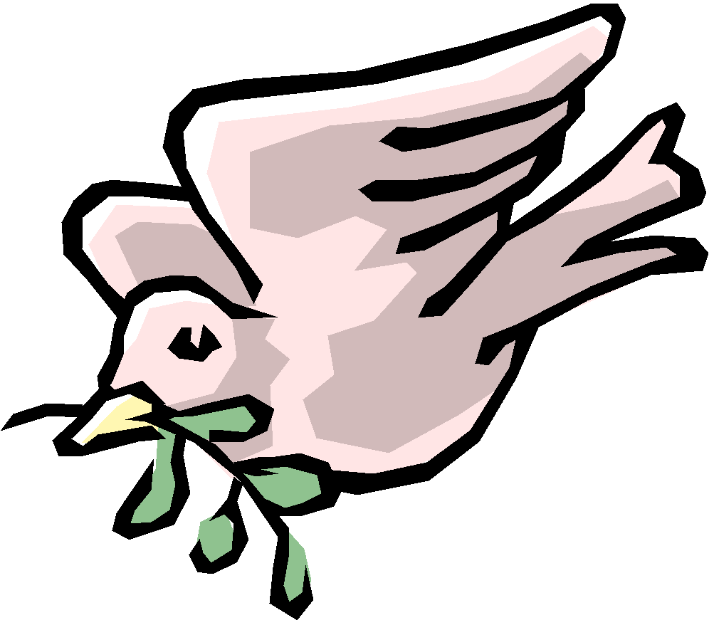 | Progression of Knowledge and Skills  Art

Nursery
Skills | Painting | Collage | Drawing/Painting
Skills | -Beginning to explore colour and mixing  -Create simple representations of objects (animals)  -Develop own ideas and decide which materials to use to express them. | -Create simple representations of objects (animals)  - Draw with increasing complexity and detail, such as representing a face with a circle and including details.  -Explore different materials freely to develop their ideas about how to us e them and what to make.  Develop own ideas and decide which materials to use to express them.  Join different materials and explore different textures. | -Create closed shapes with continuous lines, and begin to use these shapes to represent objects.  -Create simple representations of people / objects  - Draw with increasing complexity and detail, such as representing a face with a circle and including details.  - Show different emotions in their drawings and paintings, like happiness, sadness, fear etc.  - Use drawing to represent ideas like movement or loud noises.
Knowledge | -Knows that tools can be used for a purpose  -Knows that artists create artwork | -Knows that artists create artwork  -Beginning to recognise that art can be expressed in a variety of ways | -Knows tools can be used for a purpose  -Knows that artists create artwork  -Beginning to recognise that art can be expressed in a variety of ways
Vocabulary | Can explain what they have drawn | -Can describe the texture of things: e,g, rough, smooth, soft, hard, sticky | Brush, paint, colour

Reception
Skills | Hand/finger prints and collage | Paint | Collage
Skills | - - Explore, use and refine a variety of artistic effects to express their ideas and feelings.  - - Develop small motor skills so that they use a range of tools competently, safely and confidently (finger painting, glue stick)  - Create, collaboratively sharing ideas (what colour for the flames?), resources and skills.  - Return to and build on their previous learning, refining ideas and developing their ability to represent them | - - Explore, use and refine a variety of artistic effects to express their ideas and feelings.(paintbrush strokes for fruit I fruit bowl)  - - Develop small motor skills so that they use a range of tools competently, safely and confidently (correct hold of paintbrush)  - Create, collaboratively sharing ideas, resources and skills  - Return to and build on their previous learning, refining ideas and developing their ability to represent them | - Explore, use and refine a variety of artistic effects to express their ideas and feelings.  - - Develop small motor skills so that they use a range of tools competently, safely and confidently (glue and scissors)  - Create, collaboratively sharing ideas, resources and skills (what pattern is on the snail shell?)  - Return to and build on their previous learning, refining ideas and developing their ability to represent them
Knowledge | Children have an awareness that artwork can be based on a range of topics/themes/ styles. | Children have an awareness that artwork can be based on a range of topics/themes/ styles. | Children have an awareness that artwork can be based on a range of topics/themes/ styles.
Vocabulary | Knows a range of colours by name  Print, paint, press, mix | Knows a range of colours by name  Colour, paint, brush, mix | Knows a range of colours by name.  Cut, stick, rip, colour
Year One
 | Drawing | Painting | Collage
Analysis of other work | Describe the work of famous, notable artists and designers  Express an opinion on the work of famous, notable artists  Use inspiration from famous, notable artists to create their own work and compare | Describe the work of famous, notable artists and designers  Express an opinion on the work of famous, notable artists  Use inspiration from famous, notable artists to create their own work and compare | Describe the work of famous, notable artists and designers  Express an opinion on the work of famous, notable artists  Use inspiration from famous, notable artists to create their own work and compare
Skills | Draw lines of varying thickness  Use shading techniques to indicate shadow  Gaining greater control of line  Can hold drawing apparatus accurately  Children imitate artwork studied | Experiment with different brushes  Experiment with different brush strokes  Identify primary colours.  Can choose primary colours to replicate those seen in other work  Children imitate artwork studied | Experiment with different found natural materials  Identify properties of different natural materials  Use these properties to design a collage  Arrange individual pieces to create an overall effect  Adjust design in the light of actual found materials (i.e. change your design because you found a different type of leaf, or different colour).  Children imitate artwork studied.
Knowledge | Know that Diane Bleck & Romero Britto are artists.  Know that still life is a picture of something that does not move.  Know that Diane Bleck uses detailed colourful illustrations with a focus on nature and  Romero Britto uses pop art to make geometric shapes and patterns.  Know that artists use shade to show shape.  Know that different types of pencil produce different effects. | Know that Alma Thomas is an artist.  Know that Alma Thomas uses bright primary colours to inspire and celebrate.  Can describe how Alma Thomas’s work is different from previous artists’ work when shown images.  Children know the primary colours. | Know that Andy Goldsworthy is an artist  Know that Andy Goldsworthy uses natural materials to create his collages and often creates them in specific places  Know that collage is a form of sculpture  Understand that a collage is created of smaller pieces, placed together to make an overall effect
Vocabulary | Line, drawing, still life, bold, size, space, shade, detail. | Red, blue, yellow, white, black, dark, light, primary colour, bright, colourful. | Primary colours, natural materials, texture, feel, rough smooth, pattern, repeat, centre, edge, spiral, circle, sculpture
Year Two
 | Drawing | Painting | Sculpture
Analysis of other work | Describe the work of famous, notable artists and designers  Express an opinion on the work of famous, notable artists and give reasons  Identify what makes a work a portrait  Use inspiration from famous, notable artists to create their own work and compare | Describe the work of famous, notable artists and designers  Express an opinion on the work of famous, notable artists and give reasons  Use inspiration from famous, notable artists to create their own work and compare | Describe the work of famous, notable artists and designers  Express an opinion on the work of famous, notable artists and give reasons  Use inspiration from famous, notable artists to create their own work and compare
Skills | Choose appropriate drawing tools for details and shading  Experiments with holding the pencil in different positions for different effects  Use a drawing frame to draw features in proportion  show an awareness of space when drawing  Use shade to indicate light and shadow  Blend colours together to indicate tone and texture  Children imitate artwork studied | Experiment with a variety of media including oil pastels  Choose appropriate-sized brushes to complete details  Mix primary colours to make secondary colours  Use cool and warm colours for contrast  Adds water to the brush to use watercolours  Uses tissue to dry off excess water  Children imitate artwork studied | use a variety of natural and manufactured materials for sculpting, e.g. clay  use a variety of techniques, e.g. rolling, cutting, pinching  use a variety of shapes, including lines and texture  use appropriate techniques to join pieces to make a whole  Children imitate artwork studied
Knowledge | Know that Charles McGee is an artist famous for his paintings and drawings of figures.  Know that Charles McGee uses oil pastels to draw.  Children know the primary colours and can name some secondary colours | Know that Katsushika Hokusai is an artist  Know that Katsushika Hokusai utilised the bokashi technique, which involves applying a gradient of colour to the foam block to create a sense of depth and texture. To understand that colours can relate to feelings (i.e. warm might be welcoming).  Knows that paint can come in different forms for different purposes (for example poster, acrylic, oil, watercolour etc.)  Children know the primary colours and can name the secondary colours too.  Understands some of the colours that are cold or warm  Can describe work as being warm or cold | Know that sculpture is the creation of models particularly by carving or moulding materials  Understand that Antony Gormley’s art is inspired by travel.  Understand what materials would be appropriate to carve with
Vocabulary | Portrait, features, detail, primary colours, secondary colours, shade and shadow, tone, oil pastel | Oil pastel, primary colours, secondary colours, shades, warm colours, cool colours, contrast, brushstroke, texture, thick, thin | sculpture, model, work of art, 3D, carving, shapes, joining, smooth, rough
Year Three
 | Drawing | Painting/Printing | Paper Sculpture
Analysis of other work | Use inspiration from famous artists to replicate a piece of work;  Reflect upon their work inspired by a famous notable artist and the development of their art skills;  Express an opinion on the work of famous, notable artists and refer to techniques and effect; | Use inspiration from famous artists to replicate a piece of work;  Reflect upon their work inspired by a famous notable artist and the development of their art skills;  Express an opinion on the work of famous, notable artists and refer to techniques and effect; | Use inspiration from reference images and natural environments to inform independent design  Reflect upon their work inspired by a reference image and the development of their art skills  Express an opinion on the work of famous, notable artists and refer to techniques and effect
Skills | Children can use ‘pointillism’ to create the appearance of blending colours  Children can continue an artwork in the style of the artist  Children create initial sketches as preparation for using different media on  Children can alternate the size, shape and proximity of dots to create different effects  Children imitate artwork studied | Experiments with the same print in different colours  replicate patterns from observations  Draw over outlines of images with accuracy  Only presses on desired areas  Keeps images still on the surface using paper clips or other appropriate methods  Children imitate artwork studied | Children can use a variety of tearing and folding techniques (i.e. pleating, spiraling)  Children can make a variety of geometric shapes  Children can choose appropriate materials based on their properties  Children can securely join pieces to construct paper sculptures using glue tabs  Children imitate reference images.
Knowledge | Children know that Paul Signac is an artist associated with post-impressionism  Is increasingly aware of cool and warm colours  Children can recognize which colours to place adjacently to combine to form a new colour  Is aware of which colours to use to create the effect of highlights and shadow. | Children know how Hundertwasser links with their topic  Know that Hundertwasser liked curves and bright colours, and based his shapes on forms of nature.  Understands how prints are produced  Knows that marks will only be made where pressure is applied  Knows that excess paint will hinder the print  Understands how to keep an image still on a surface as pressure is applied | To know that Helen Musselwhite is a paper-based artist known for paper sculptures.  Know that Helen Musselwhite uses nature for inspiration.  Children know different materials have different properties
Vocabulary | Light, dark, shade, blend, press, outline, tone, pointillism, dot, effect, impression, combine, dense and sparse, highlight, shadow, foreground, background. | Motif, patter, repetition, mirror, offset, colour, shape, monoprint, printing tiles, inking rollers | Paper, structure, pleat, controlled tear, fringe, cone, cylinder, slot, prism, curl, spiral, nature
Year Four
 | Drawing | Painting | 3D Sculpture
Analysis of other art work | use inspiration from famous artists to replicate a piece of work  reflect upon their work inspired by a famous notable artist and the development of their art skills  express an opinion on the work of famous artists | use inspiration from famous artists to replicate a piece of work  reflect upon their work inspired by a famous notable artist and the development of their art skills  express an opinion on the work of famous artists | use inspiration from famous artists to replicate a piece of work  reflect upon their work inspired by a famous notable artist and the development of their art skills  express an opinion on the work of famous artists
Skills | Experiment with weighting lines for different effects  use shading to show light and shadow effects  experiments with different materials to draw, e.g. pastels, charcoal, chalk, ink.  Experiment with moving the drawing instrument from the wrist, elbow and shoulder to create smooth lines  show an awareness of space when drawing  Children imitate artwork studied | Plan and create a composition using a range of geometric shapes  Use colour strategically to emphasise and contrast  Begin to create tertiary colours by mixing and blending.  Demonstrate an awareness of negative space.  Children’s work is inspired by artist but does not replicate the work studied | Children can use clay and other modelling materials to create and join shapes.  Children can design and create sculptures by joining smaller 3d pieces  Make informed decisions about what tools and techniques to use to shape and join pieces  Join clay pieces securely by scoring and bonding  Children’s work is inspired by artist but does not replicate the work studied
Knowledge | Know that Picasso is an artist and that line drawings are one element of his output.  Know that sketch lines are used in a wide range of artistic pieces for different effects  Know that lines suggest movement and direction  Know that line is a key element of art. | Understands how the work of Wassily Kandinsky links with their topic  To understand that prints can be made using a collagraph  Has been introduced to the colour wheel, and is beginning to gain an understanding of the relationship between some colours  Know that shape and colour are key elements of art | Understands how the work of Antony Gormley links with their topic.  Understand the local significance of Another Place at Crosby.  Know that Gormley’s sculptures are connected to places (e.g. The Angel of the North).  Know that form is a key element of art.
Vocabulary | Drafting stick, charcoal, chalk, ink, outline, sketch, weight | Geometric, shape, line, triangle, square, trapezium, oval, circle etc.., direction, movement, outline, bold, contrast. | Cone, cylinder, sphere, spheroid, score, blend, shape, knife, dry, form
Year Five
 | Drawing and Painting | Painting | Textiles
Analysis of other art work | give detailed observations about an artist’s style, with reference to the elements of art  Offer facts about notable artists’ lives and connect them to their work  lLcate artists’ work within the context of broader artistic movements and moments (i.e. op-art, neo-expressionism) | give detailed observations about notable artists’ work  Offer facts about notable artists’, artisans’ and designers’ lives  Locate artists’ work within the context of broader artistic movements and moments (i.e. impressionism) | give detailed observations about notable artists’, artisans’ and designers’ work  offer facts about notable artists’, artisans’ and designers’ lives
Skills | Create a colour palette, demonstrating mixing techniques  Children can create the impression of 3D forms using parallel contour lines and 2D shapes  Children’s knowledge of the colour wheel is increasing, so too is their understanding of similar and complimentary colours  Strokes are consistent with the shape of the object being coloured e.g. swirled, spiral, straight, horizontal, vertical  Children are increasingly using more precise implements for the task (e.g. smaller brushes, more refined tips) | Children have a good enough understanding of the colour wheel to know which colours are similar and complimentary  Children use their knowledge of the above to blend two colours  Children consider where a light source within an art-piece is positioned, to get the highlights and shadows accurate  Children use complimentary colours (rather than simply adding black) to create the impression of shadows  Colouring is accurate and does not go over the desired border that is being coloured  Direction of colouring is consistent with the shape of the object being coloured e.g. swirled, spiral, straight, horizontal, vertical  Background is completed first and built upon into the foreground  Children can use ICT to create a version of their artwork, using the same skills | Design a pattern or scene in advance, rehearsing it for consistency  Select and use appropriate tools to spread wax  Use primary coloured dyes to create secondary and tertiary colours as desired  Consider proportion and add detail last  Plan and design a batik  Refine work as they go to ensure precision
Knowledge | Understands how Bridget Riley links with their topic  Can identify similarities and themes within the work of Bridget Riley  Understands that Op-Art is a form of abstract art in which optical illusions create the effect of movement  Understand that Op-Art as a movement foregrounds the role of the viewer in creating the meaning of the artwork  Children’s work is inspired by artist but does not directly replicate the work | Understands how Monet links with their topic  Can identify and name some of Monet’s famous artworks  Can identify similarities and themes within Monet’s work  Can describe Monet’s work as being central to the formation of impressionism, which emphasises the perception of nature  Children’s work is inspired by artist but does not replicate the work | Understands how Chuah Thean Teng links with their topic  Understands Chuah Thean Teng is credited with the creation of Batik as a modern artistic technique, and that his artwork typically represents scenes from Malaysia, where he lived  Can describe the work of Chuah Thean Teng and some of its major themes  Understands that batik is made by drawing dots or lines of wax which prevent the dye from soaking into the material  Children’s work is inspired by artist but does not directly replicate the work
Vocabulary | Op-Art, illusion, effect, concentric and parallel, highlights, shadows, similar (or analogous) and complimentary colours | Background, foreground, blend, block, stroke, shade, pastel, tone, similar (or analogous) colour | Batik, wax, dye, resist, soak, pattern, outline, blocking, material, textiles
Year Six
 | Printing (Choice of print up to pupil) | Drawing (optional medium for colouring) | Optional (choice of medium up to pupil)
Analysis of other art work | give detailed observations about notable artists’, artisans’ and designers’ work  offer facts about notable artists’, artisans’ and designers’ lives | give detailed observations about notable artists’, artisans’ and designers’ work  offer facts about notable artists’, artisans’ and designers’ lives | give detailed observations about notable artists’, artisans’ and designers’ work  offer facts about notable artists’, artisans’ and designers’ lives
Skills | Children can compose their artwork, working from the background to the foreground  Children can consider perspective, thinking about where the attention of the viewer should be directed  Children can create tonal contrasts to create desired atmosphere (dramatic or tranquil).  Children select appropriate implements for the task with increasing independence, using increasingly precise tools for drafting and painting  Children can blend primary colours to produce secondary and tertiary colours  Children can use white and black, and to dilute or concentrate watercolours to alter the tone  Children can employ a variety of watercolour techniques (lifting, blotting, wax, underpainting, wet blending) to create a desired effect  Children can consider the placement of light sources within their work and use this to inform the placement of highlights and shadows  Children’s work is inspired by artist but does not directly replicate the work | use a variety of techniques to add effects  depict movement and perspective in drawings  use a variety of tools and select the most appropriate  When using pencil, children decide what tone is most appropriate for the effect intended  Children use a piece of paper to avoid getting fingerprints or smudges over their work  Children use geometric shapes to represent buildings  Colours are simple and clearly inspired by Lowry’s colour palette.  Art style is inspired by Lowry but does not replicate his work. Final pieces depict personal experience. | To explore the method of direct carving.  Use a variety of tools and select the most appropriate one.  Explore a variety of textures and choose their favourite based on their knowledge.  Abstract art sculptures don’t look like a realistic representation of the things that inspired them.
Knowledge | Children know why William Turner links with their topic  Children know that Turner was a Romantic painter who worked primarily with watercolours and is especially know for painting landscapes and seascapes  Children know that Turner was known as ‘the painter of light’, and can explain how this helps us understand his work  Children know why Turner is significant for the history of modern art | children know why Lowry links with their topic  children know the era of Lowry and the significance of industrialisation and urbanisation  children understand the colour wheel and can name analogous (similar) and opposite colours  Children recognise geometric shapes within Lowry’s work | Understands how artist links to their choice of medium.  To know that Barbara Hepworth is an abstract artist.  To know that Hepworth’s work was inspired by specific places and natural features, but many were based on the ‘feelings’ of these geographical features.
Vocabulary | Background, foreground, Romantic, perspective, landscape, seascape, dramatic, tranquil, atmosphere, depth, chiaroscuro, luminosity | Motion, industrial, opposite colours, similar (or analogous) colours, matchstick men, shape, hard, light, portrait, tone | Sculpture, abstract, texture, carving, materials, form, modern, shape, line, balance.

